**Program to find area and circumference of circle**

import java.util.Scanner;

public class CircleCalculator {

public static void main(String[] args) {

Scanner scanner = new Scanner(System.in);

// Ask user for the radius

System.out.print("Enter the radius of the circle: ");

double radius = scanner.nextDouble();

double area = Math.PI * radius * radius;

double circumference = 2 * Math.PI * radius;

// Display results

System.out.println("Area of the circle: " + area);

System.out.println("Circumference of the circle: " + circumference);

System.out.println("riddhi agrawal");

System.out.println("0873CS231098");

scanner.close();

}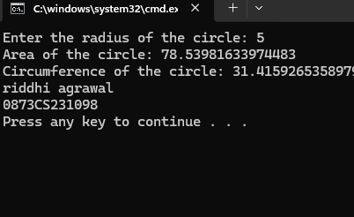

}

**Program to find the simple interest**

import java.util.Scanner;

public class SimpleInterest {

public static void main(String[] args) {

Scanner scanner = new Scanner(System.in);

System.out.print("Enter the principal amount: ");

double principal = scanner.nextDouble();

System.out.print("Enter the rate of interest (per year): ");

double rate = scanner.nextDouble();

System.out.print("Enter the time period (in years): ");

double time = scanner.nextDouble();

double simpleInterest = (principal * rate * time) / 100;

System.out.println("Simple Interest: " + simpleInterest);

scanner.close();

}

}

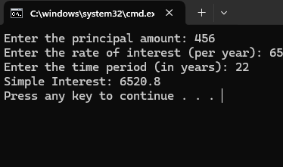

**Program to reverse a given number.**

import java.io.*;

// Driver Class

class Reverse

{

// Function to reverse the number

static int reverse(int n)

{

// reversed number

int rev = 0;

// remainder

int rem;

while (n > 0) {

rem = n % 10;

rev = (rev * 10) + rem;

n = n / 10;

}

return rev;

}

// Driver Function

public static void main(String[] args)

{

int n = 4526;

System.out.println("Reversed Number is: "

+ reverse(n));

System.out.println("Riddhi agrawal 0873cs231098") ;

}

}

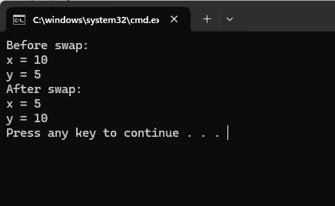

**. Program to find greatest in 3 numbers**

import java.util.Scanner;

public class GreatestOfThree {

public static void main(String[] args) {

Scanner scanner = new Scanner(System.in);

// Input three numbers

System.out.print("Enter first number: ");

int a = scanner.nextInt();

System.out.print("Enter second number: ");

int b = scanner.nextInt();

System.out.print("Enter third number: ");

int c = scanner.nextInt();

// Find the greatest

int greatest;

if (a >= b && a >= c) {

greatest = a;

} else if (b >= a && b >= c) {

greatest = b;

} else {

greatest = c;

}

System.out.println("The greatest number is: " + greatest);

System.out.println("riddhi agrawal");

System.out.println("0873CS231098");

scanner.close();

}

}

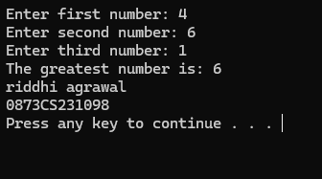**Accept person age(int), gender(int 1 for male and 0 for female), then check whether person is eligible for marriage or not.**

import java.util.Scanner;

public class MarriageEligibility {

public static void main(String[] args) {

Scanner scanner = new Scanner(System.in);

// Input age and gender

System.out.print("Enter age: ");

int age = scanner.nextInt();

System.out.print("Enter gender (1 for Male, 0 for Female): ");

int gender = scanner.nextInt();

// Check eligibility

if (gender == 1) { // Male

if (age >= 21) {

System.out.println("Eligible for marriage (Male).");

} else {

System.out.println("Not eligible for marriage (Male).");

}

} else if (gender == 0) { // Female

if (age >= 23) {

System.out.println("Eligible for marriage (Female).");

} else {

System.out.println("Not eligible for marriage (Female).");

}

} else {

System.out.println("Invalid gender input. Use 1 for Male, 0 for Female.");

}

System.out.println("riddhi");

System.out.println("0873CS231098");

scanner.close();

}

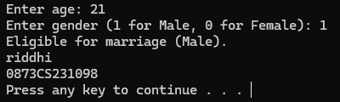}

**Program to check that entered year is leap year or not.**

import java.util.Scanner;

public class LeapYearChecker {

public static void main(String[] args) {

Scanner scanner = new Scanner(System.in);

// Input year

System.out.print("Enter a year: ");

int year = scanner.nextInt();

// Check leap year

if ((year % 4 == 0 && year % 100 != 0) || (year % 400 == 0)) {

System.out.println(year + " is a leap year.");

} else {

System.out.println(year + " is not a leap year.");

}

System.out.println("riddhi agrawal");

System.out.println("0873CS231098");

scanner.close();

}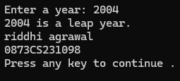

}

**. Print all prime numbers between two given numbers**

import java.util.Scanner;

public class PrimeRange {

// Method to check if a number is prime

public static boolean isPrime(int num) {

if (num <= 1) return false;

for (int i = 2; i <= Math.sqrt(num); i++) {

if (num % i == 0)

return false;

}

return true;

}

public static void main(String[] args) {

Scanner scanner = new Scanner(System.in);

// Input range

System.out.print("Enter starting number: ");

int start = scanner.nextInt();

System.out.print("Enter ending number: ");

int end = scanner.nextInt();

System.out.println("Prime numbers between " + start + " and " + end + ":");

// Print prime numbers in the range

for (int i = start; i <= end; i++) {

if (isPrime(i)) {

System.out.print(i + " ");

}

}

System.out.println("riddhi agrawal");

System.out.println("0873CS231098");

scanner.close();

}

}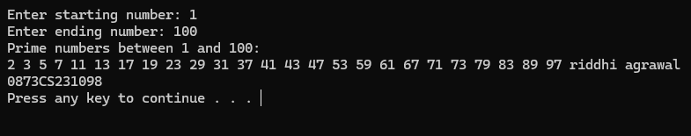

**. Program to reverse a given number**

import java.io.*;

// Driver Class

class Reverse

{

// Function to reverse the number

static int reverse(int n)

{

// reversed number

int rev = 0;

// remainder

int rem;

while (n > 0) {

rem = n % 10;

rev = (rev * 10) + rem;

n = n / 10;

}

return rev;

}

// Driver Function

public static void main(String[] args)

{

int n = 4526;

System.out.println("Reversed Number is: "

+ reverse(n));

System.out.println("Riddhi agrawal 0873cs231098") ;

}

}



**Program to check whether number is prime or not**

import java.util.Scanner;

public class PrimeCheck {

public static void main(String[] args) {

Scanner scanner = new Scanner(System.in);

// Input number

System.out.print("Enter a number: ");

int number = scanner.nextInt();

boolean isPrime = true;

// Check for edge cases

if (number <= 1) {

isPrime = false;

} else {

// Check divisibility from 2 to sqrt(number)

for (int i = 2; i <= Math.sqrt(number); i++) {

if (number % i == 0) {

isPrime = false;

break;

}

}

}

// Display result

if (isPrime) {

System.out.println(number + " is a prime number.");

} else {

System.out.println(number + " is not a prime number.");

}

System.out.println("riddhi agrawal");

System.out.println("0873CS231098");

scanner.close();

}

}

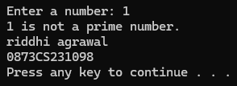

**Program to find multiplication of two 3X3 matrice**

public class MatrixMultiplication {

public static void main(String[] args) {

int[][] matrix1 = {

{1, 2, 3},

{4, 5, 6},

{7, 8, 9}

};

int[][] matrix2 = {

{9, 8, 7},

{6, 5, 4},

{3, 2, 1}

};

int[][] result = multiplyMatrices(matrix1, matrix2);

System.out.println("Resultant Matrix:");

printMatrix(result);

}

public static int[][] multiplyMatrices(int[][] matrix1, int[][] matrix2) {

int rows1 = matrix1.length;

int cols1 = matrix1[0].length;

int cols2 = matrix2[0].length;

int[][] result = new int[rows1][cols2];

for (int i = 0; i < rows1; i++) {

for (int j = 0; j < cols2; j++) {

for (int k = 0; k < cols1; k++) {

result[i][j] += matrix1[i][k] * matrix2[k][j];

}

}

}

return result;

}

public static void printMatrix(int[][] matrix) {

for (int[] row : matrix) {

for (int element : row) {

System.out.print(element + " ");

}

System.out.println();

}System.out.println("riddhi agrawal , 0873CS231098");

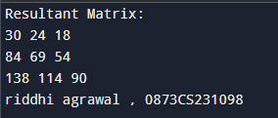 }

**Program to make a arrya in decending order**

import java.util.Scanner;

public class Main

{

public static void main(String[] args)

{

Scanner sc=new Scanner(System.in);

int n; //Array Size Declaration

System.out.println("Enter the number of elements :");

n=sc.nextInt(); //Array Size Initialization

Integer arr[]=new Integer[n]; //Array Declaration

System.out.println("Enter the elements of the array :");

for(int i=0;i<n;i++) //Array Initialization

{

arr[i]=sc.nextInt();

}

int temp = 0; //Temporary variable to store the element

for (int i = 0; i < arr.length; i++) //Holds each Array element

{

for (int j = i+1; j < arr.length; j++) //compares with remaining Array elements

{

if(arr[i] < arr[j]) //Compare and swap

{

temp = arr[i];

arr[i] = arr[j];

arr[j] = temp;

}

}

}

System.out.println();

//Displaying elements of array after sorting

System.out.println("Elements of array sorted in descending order: ");

for (int i = 0; i < arr.length; i++)

{

System.out.print(arr[i] + " ");

} System.out.println("Riddhi agrawal 0873cs231098") ;

}

}

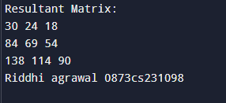

**Program to print transpose of a matrix.**

**Object Oriented Programming , Classes, Objects ,Methods, Constructor**

import java.util.Scanner;

class Matrix {

private int[][] matrix;

private int rows;

private int cols;

// Constructor

public Matrix(int rows, int cols) {

this.rows = rows;

this.cols = cols;

this.matrix = new int[rows][cols];

}

// Method to input matrix elements

public void inputMatrix(Scanner scanner) {

System.out.println("Enter matrix elements:");

for (int i = 0; i < rows; i++) {

for (int j = 0; j < cols; j++) {

matrix[i][j] = scanner.nextInt();

}

}

}

// Method to display matrix

public void displayMatrix() {

for (int i = 0; i < rows; i++) {

for (int j = 0; j < cols; j++) {

System.out.print(matrix[i][j] + " ");

}

System.out.println();

}

}

// Method to find transpose of the matrix

public Matrix transpose() {

Matrix transposedMatrix = new Matrix(cols, rows);

for (int i = 0; i < rows; i++) {

for (int j = 0; j < cols; j++) {

transposedMatrix.matrix[j][i] = this.matrix[i][j];

}

}

return transposedMatrix;

}

}

public class Main {

public static void main(String[] args) {

Scanner scanner = new Scanner(System.in);

System.out.print("Enter number of rows: ");

int rows = scanner.nextInt();

System.out.print("Enter number of columns: ");

int cols = scanner.nextInt();

Matrix matrix = new Matrix(rows, cols);

matrix.inputMatrix(scanner);

System.out.println("Original matrix:");

matrix.displayMatrix();

Matrix transposedMatrix = matrix.transpose();

System.out.println("Transposed matrix:");

transposedMatrix.displayMatrix();

System.out.println("Riddhi agrawal 0873cs231098") ;

}

}

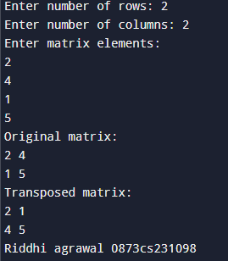

**Program to print a table of any number**

import java.util.Scanner;

public class MultiplicationTable {

public static void main(String[] args) {

Scanner scanner = new Scanner(System.in);

System.out.print("Enter a number: ");

int number = scanner.nextInt();

System.out.println("Multiplication table for " + number + ":");

for (int i = 1; i <= 10; i++) {

System.out.println(number + " * " + i + " = " + (number * i));

}

scanner.close();

System.out.println("Riddhi agrawal 0873cs231098") ;

}}

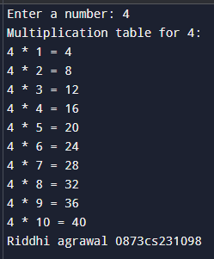

**Write a program which accepts days(eg. 670 days) as integer and display total number**

**of years, months and days in it.**

import java.util.Scanner;

public class DaysConverter {

public static void main(String[] args) {

Scanner scanner = new Scanner(System.in);

System.out.print("Enter the number of days: ");

int totalDays = scanner.nextInt();

int years = totalDays / 365;

int remainingDays = totalDays % 365;

int months = remainingDays / 30;

int days = remainingDays % 30;

System.out.println(totalDays + " days is equal to:");

System.out.println(years + " years, " + months + " months, and " + days + " days.");

scanner.close();

} System.out.println("Riddhi agrawal 0873cs231098") ;

}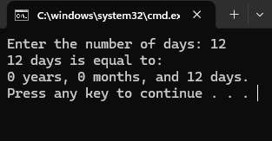

**. Program to convert temperature from Fahrenheit to Celsius as C= 5*(f-32)/9**

import java.util.Scanner;

public class FahrenheitToCelsius {

public static void main(String[] args) {

Scanner scanner = new Scanner(System.in);

System.out.print("Enter temperature in Fahrenheit: ");

double fahrenheit = scanner.nextDouble();

double celsius = (fahrenheit - 32) * 5.0 / 9.0;

System.out.println(fahrenheit + " Fahrenheit is equal to " + celsius + " Celsius");

scanner.close();

} System.out.println("Riddhi agrawal 0873cs231098") ;

}

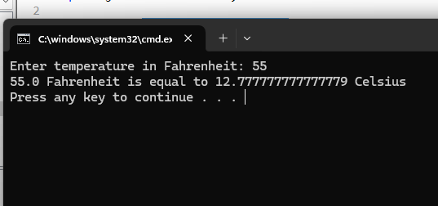

**Program to calculate sum of 5 subjects &amp; find percentage.**

import java.util.Scanner;

public class CalculateMarks {

public static void main(String[] args) {

Scanner scanner = new Scanner(System.in);

int[] marks = new int[5];

int totalMarks = 0;

System.out.println("Enter marks for 5 subjects:");

for (int i = 0; i < 5; i++) {

System.out.print("Subject " + (i + 1) + ": ");

marks[i] = scanner.nextInt();

totalMarks += marks[i];

}

double percentage = (double) totalMarks / 500 * 100;

System.out.println("Total Marks: " + totalMarks);

System.out.println("Percentage: " + percentage + "%");

scanner.close();

} System.out.println("Riddhi agrawal 0873cs231098") ;

}

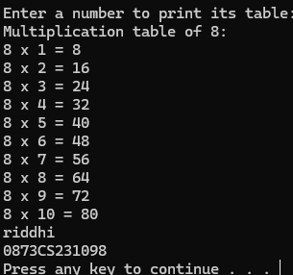

**. Program to swap two no’s without using third variable**

public class SwapNumbers {

public static void main(String[] args) {

int x = 10;

int y = 5;

System.out.println("Before swap:");

System.out.println("x = " + x);

System.out.println("y = " + y);

// Swap logic

x = x + y;

y = x - y;

x = x - y;

System.out.println("After swap:");

System.out.println("x = " + x);

System.out.println("y = " + y);

}System.out.println("riddhi agrawal");

System.out.println("0873CS231098");

}



**Calculate series : 1 2 +2 2 +3 2 +4 2 +.........+n 2**

import java.util.Scanner;

public class SquareSeriesSum {

public static void main(String[] args) {

Scanner scanner = new Scanner(System.in);

// Input n

System.out.print("Enter the value of n: ");

int n = scanner.nextInt();

int sum = 0;

// Calculate sum of squares

for (int i = 1; i <= n; i++) {

sum += i * i;

}

// Display result

System.out.println("Sum of the series 1² + 2² + ... + " + n + "² = " + sum);

System.out.println("riddhi agrawal");

System.out.println("0873CS231098");

scanner.close();

}

}

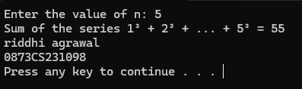

**Calculate sum of Lucas series (up to 10 terms) :**

**1, 2, 3, 6, 11, 20 ,........**

public class LucasSeriesSum {

public static void main(String[] args) {

int n = 10; // Number of terms

int sum = 0;

int first = 1;

int second = 2;

System.out.print("Lucas Series: ");

for (int i = 0; i < n; i++) {

System.out.print(first + " ");

sum += first;

int next = first + second;

first = second;

second = next;

}

System.out.println("\nSum of the Lucas series: " + sum);

System.out.println("Riddhi agrawal 0873cs231098") ;

}}

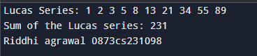

**Program to show sum and average of 10 element array. Accept array elements from**

**user.**

import java.util.Scanner;

public class ArraySumAverage {

public static void main(String[] args) {

Scanner scanner = new Scanner(System.in);

int[] numbers = new int[10];

int sum = 0;

System.out.println("Enter 10 numbers:");

for (int i = 0; i < numbers.length; i++) {

System.out.print("Number " + (i + 1) + ": ");

numbers[i] = scanner.nextInt();

sum += numbers[i];

}

double average = (double) sum / numbers.length;

System.out.println("Sum of the numbers: " + sum);

System.out.println("Average of the numbers: " + average);

scanner.close();

System.out.println("riddhi agrawal");

System.out.println("0873CS231098");

}

}

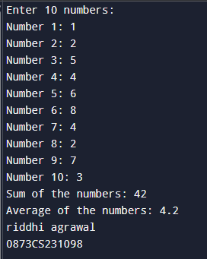

**Create a array of 17 elements in 5 rows. And calculate sum of all elements**

public class ArraySum {

public static void main(String[] args) {

int[][] array = new int[5][];

// Initialize rows with varying lengths to accommodate 17 elements

array[0] = new int[4];

array[1] = new int[4];

array[2] = new int[3];

array[3] = new int[3];

array[4] = new int[3];

// Fill the array with sample values

int count = 1;

for (int i = 0; i < array.length; i++) {

for (int j = 0; j < array[i].length; j++) {

array[i][j] = count++;

}

}

// Calculate the sum of all elements

int sum = 0;

for (int i = 0; i < array.length; i++) {

for (int j = 0; j < array[i].length; j++) {

sum += array[i][j];

}

}

// Print the array and the sum

System.out.println("Array elements:");

for (int i = 0; i < array.length; i++) {

for (int j = 0; j < array[i].length; j++) {

System.out.print(array[i][j] + " ");

}

System.out.println();

}

System.out.println("Sum of all elements: " + sum);

System.out.println("riddhi agrawal");

System.out.println("0873CS231098");

}

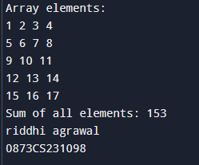

**Write a program to find the area and circumference of a circle.**

import java.util.Scanner;

public class CircleCalculator {

public static void main(String[] args) {

Scanner scanner = new Scanner(System.in);

// Ask user for the radius

System.out.print("Enter the radius of the circle: ");

double radius = scanner.nextDouble();

double area = Math.PI * radius * radius;

double circumference = 2 * Math.PI * radius;

// Display results

System.out.println("Area of the circle: " + area);

System.out.println("Circumference of the circle: " + circumference);

System.out.println("riddhi agrawal");

System.out.println("0873CS231098");

scanner.close();

}

}

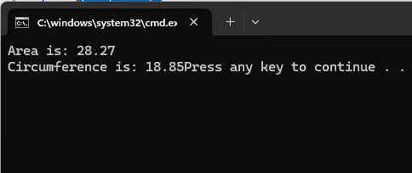

**Write a program to calculate simple interest.**

import java.util.Scanner;

public class SimpleInterest {

public static void main(String[] args) {

Scanner scanner = new Scanner(System.in);

System.out.print("Enter the principal amount: ");

double principal = scanner.nextDouble();

System.out.print("Enter the rate of interest (per year): ");

double rate = scanner.nextDouble();

System.out.print("Enter the time period (in years): ");

double time = scanner.nextDouble();

double simpleInterest = (principal * rate * time) / 100;

System.out.println("Simple Interest: " + simpleInterest);

scanner.close();

}

}



**Write a program to calculate the sum of 5 subjects and find the percentage.**

import java.util.Scanner;

public class CalculateMarks {

public static void main(String[] args) {

Scanner scanner = new Scanner(System.in);

int[] marks = new int[5];

int totalMarks = 0;

System.out.println("Enter marks for 5 subjects:");

for (int i = 0; i < 5; i++) {

System.out.print("Subject " + (i + 1) + ": ");

marks[i] = scanner.nextInt();

totalMarks += marks[i];

}

double percentage = (double) totalMarks / 500 * 100;

System.out.println("Total Marks: " + totalMarks);

System.out.println("Percentage: " + percentage + "%");

scanner.close();

}

}

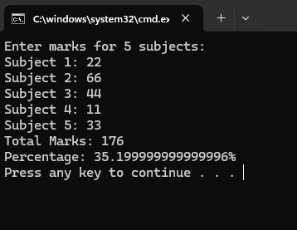

**Write a Java program to create an ArrayList, add some colors (as strings), and print the collection.**

import java.util.ArrayList;

public class ColorList {

public static void main(String[] args) {

// Create an ArrayList to store colors (strings)

ArrayList<String> colors = new ArrayList<>();

// Add colors to the ArrayList

colors.add("Red");

colors.add("Green");

colors.add("Blue");

colors.add("Yellow");

colors.add("Black");

// Print the ArrayList

System.out.println("Colors: " + colors);

System.out.println("Riddhi agrawal 0873cs231098") ;

}

}



**Write a program to iterate through all elements in an ArrayList in javaimport java.util.ArrayList;**

import java.util.Iterator;

import java.util.ListIterator;

public class ArrayListIteration {

public static void main(String[] args) {

ArrayList<String> arrayList = new ArrayList<>();

arrayList.add("Element 1");

arrayList.add("Element 2");

arrayList.add("Element 3");

// 1. Using a for loop with index

System.out.println("Using for loop:");

for (int i = 0; i < arrayList.size(); i++) {

System.out.println(arrayList.get(i));

}

// 2. Using a for-each loop

System.out.println("\nUsing for-each loop:");

for (String element : arrayList) {

System.out.println(element);

}

// 3. Using an Iterator

System.out.println("\nUsing Iterator:");

Iterator<String> iterator = arrayList.iterator();

while (iterator.hasNext()) {

System.out.println(iterator.next());

}

// 4. Using a ListIterator (allows bidirectional traversal)

System.out.println("\nUsing ListIterator:");

ListIterator<String> listIterator = arrayList.listIterator();

// Forward traversal

System.out.println("Forward Traversal");

while (listIterator.hasNext()) {

System.out.println(listIterator.next());

}

// Backward traversal

System.out.println("Backward Traversal");

while (listIterator.hasPrevious()) {

System.out.println(listIterator.previous());

}

// 5. Using Java 8 Streams

System.out.println("\nUsing Streams:");

arrayList.stream().forEach(System.out::println);

System.out.println("riddhi agrawal");

System.out.println("0873CS231098");

}

}

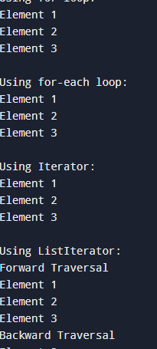

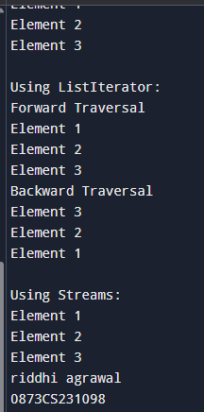

**Write a Java program to insert an element into the ArrayList at the first position.**

import java.util.ArrayList;

public class InsertAtFirst {

public static void main(String[] args) {

// Create an ArrayList

ArrayList<String> list = new ArrayList<>();

list.add("apple");

list.add("banana");

list.add("cherry");

// Element to insert at the first position

String newElement = "mango";

// Insert the element at the first position (index 0)

list.add(0, newElement);

// Print the updated ArrayList

System.out.println(list);

System.out.println("riddhi agrawal");

System.out.println("0873CS231098");

}

}

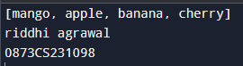

**Write a Java program to retrieve an element at a specified index from a given ArrayList.**

import java.util.ArrayList;

public class RetrieveElement {

public static void main(String[] args) {

// Create an ArrayList of Strings

ArrayList<String> arrayList = new ArrayList<>();

arrayList.add("Apple");

arrayList.add("Banana");

arrayList.add("Cherry");

arrayList.add("Date");

// Specify the index of the element to retrieve

int index = 2;

// Retrieve the element at the specified index

try {

String element = arrayList.get(index);

System.out.println("Element at index " + index + ": " + element);

} catch (IndexOutOfBoundsException e) {

System.out.println("Index " + index + " is out of bounds.");

}

// Example with an out-of-bounds index

int invalidIndex = 5;

try {

String element = arrayList.get(invalidIndex);

System.out.println("Element at index " + invalidIndex + ": " + element);

} catch (IndexOutOfBoundsException e) {

System.out.println("Index " + invalidIndex + " is out of bounds.");

System.out.println("riddhi agrawal");

System.out.println("0873CS231098");

}}

}

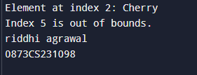

**Write a Java program to update an ArrayList element by a given element**

import java.util.ArrayList;

import java.util.List;

public class UpdateArrayListElement {

public static void main(String[] args) {

// Create an ArrayList of Strings

List<String> colors = new ArrayList<>();

colors.add("Red");

colors.add("Green");

colors.add("Blue");

colors.add("Yellow");

System.out.println("Original ArrayList: " + colors);

// Specify the index and the new element

int indexToUpdate = 1;

String newColor = "Orange";

// Update the element at the specified index

if (indexToUpdate >= 0 && indexToUpdate < colors.size()) {

colors.set(indexToUpdate, newColor);

System.out.println("ArrayList after update: " + colors);

} else {

System.out.println("Invalid index");

}

System.out.println("riddhi agrawal");

System.out.println("0873CS231098");

}

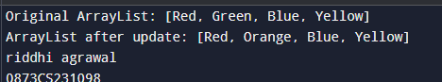

**Write a Java program to remove the third element from an ArrayList.**

import java.util.ArrayList;

public class RemoveThirdElement {

public static void main(String[] args) {

// Create an ArrayList of Strings

ArrayList<String> list = new ArrayList<>();

list.add("First");

list.add("Second");

list.add("Third");

list.add("Fourth");

list.add("Fifth");

// Print the original ArrayList

System.out.println("Original ArrayList: " + list);

// Remove the element at index 2 (third element)

if (list.size() > 2) {

list.remove(2);

} else {

System.out.println("ArrayList does not have a third element.");

}

// Print the modified ArrayList

System.out.println("ArrayList after removing the third element: " + list);

System.out.println("riddhi agrawal");

System.out.println("0873CS231098");

}

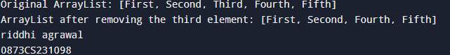

**Write a Java program to search for an element in an ArrayList in java**

import java.util.ArrayList;

public class SearchArrayList {

public static void main(String[] args) {

ArrayList<String> list = new ArrayList<>();

list.add("Apple");

list.add("Banana");

list.add("Cherry");

list.add("Date");

String searchElement = "Banana";

boolean found = false;

// Method 1: Using contains()

if (list.contains(searchElement)) {

System.out.println("Element '" + searchElement + "' found in the list (using contains()).");

found = true;

}

// Method 2: Using indexOf()

int index = list.indexOf(searchElement);

if (index != -1) {

System.out.println("Element '" + searchElement + "' found at index " + index + " (using indexOf()).");

found = true;

}

// Method 3: Using a loop

if(!found) {

for (String element : list) {

if (element.equals(searchElement)) {

System.out.println("Element '" + searchElement + "' found in the list (using a loop).");

found = true;

break;

}

}

}

if (!found) {

System.out.println("Element '" + searchElement + "' not found in the list.");

}

System.out.println("riddhi agrawal");

System.out.println("0873CS231098");

}

}

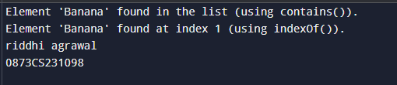

**Write a Java program to sort a given ArrayList.**

import java.util.ArrayList;

import java.util.Collections;

public class SortArrayList {

public static void main(String[] args) {

ArrayList<Integer> numbers = new ArrayList<>();

numbers.add(5);

numbers.add(2);

numbers.add(8);

numbers.add(1);

numbers.add(9);

System.out.println("ArrayList before sorting: " + numbers);

// Sort the ArrayList in ascending order

Collections.sort(numbers);

System.out.println("ArrayList after sorting: " + numbers);

// Sort in descending order

Collections.sort(numbers, Collections.reverseOrder());

System.out.println("ArrayList after sorting in reverse order: " + numbers);

System.out.println("riddhi agrawal");

System.out.println("0873CS231098");

}

}

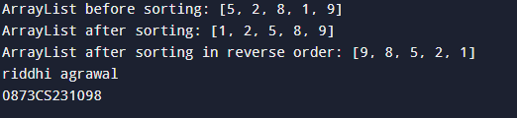

**Write a Java program to copy one array list into another.**

import java.io.*;

import java.util.ArrayList;

class GFG {

public static void main(String[] args)

{

ArrayList<Integer> gfg = new ArrayList<>();

gfg.add(10);

gfg.add(21);

gfg.add(22);

gfg.add(35);

ArrayList<Integer> gfg2 = gfg;

System.out.println(

"-----Iterating over the second ArrayList----");

for (Integer value : gfg2) {

System.out.println(value);

}

gfg2.set(2, 23);

System.out.println("third element of first list ="

+ gfg.get(2));

System.out.println("third element of second list ="

+ gfg2.get(2));

System.out.println("riddhi agrawal");

System.out.println("0873CS231098");

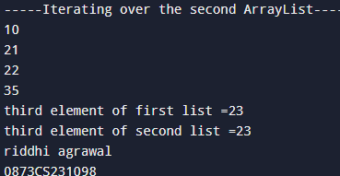

**. Write a Java program to shuffle elements in an array list.**

import java.util.ArrayList;

import java.util.Collections;

import java.util.List;

public class ShuffleArrayList {

public static void main(String[] args) {

// Create an ArrayList of Integers

List<Integer> numbers = new ArrayList<>();

numbers.add(1);

numbers.add(2);

numbers.add(3);

numbers.add(4);

numbers.add(5);

System.out.println("Original ArrayList: " + numbers);

// Shuffle the ArrayList

Collections.shuffle(numbers);

System.out.println("Shuffled ArrayList: " + numbers);

System.out.println("riddhi agrawal");

System.out.println("0873CS231098");

}

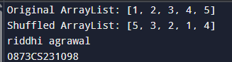

**Write a Java program to reverse elements in an array list.**

import java.util.ArrayList;

import java.util.Collections;

import java.util.List;

public class ReverseArrayList {

public static void main(String[] args) {

// Create an ArrayList

List<Integer> list = new ArrayList<>();

list.add(1);

list.add(2);

list.add(3);

list.add(4);

list.add(5);

System.out.println("Original ArrayList: " + list);

// Method 1: Using Collections.reverse()

Collections.reverse(list);

System.out.println("Reversed ArrayList (using Collections.reverse()): " + list);

// Method 2: Reversing in-place

List<Integer> list2 = new ArrayList<>();

list2.add(1);

list2.add(2);

list2.add(3);

list2.add(4);

list2.add(5);

for (int i = 0; i < list2.size() / 2; i++) {

int temp = list2.get(i);

list2.set(i, list2.get(list2.size() - i - 1));

list2.set(list2.size() - i - 1, temp);

}

System.out.println("Reversed ArrayList (in-place): " + list2);

System.out.println("riddhi agrawal");

System.out.println("0873CS231098");

}

}

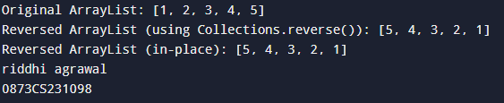

**Write a Java program to extract a portion of an array list**

import java.util.ArrayList;

import java.util.List;

public class ExtractArrayList {

public static void main(String[] args) {

// Create an ArrayList of Strings

ArrayList<String> originalList = new ArrayList<>();

originalList.add("Apple");

originalList.add("Banana");

originalList.add("Cherry");

originalList.add("Date");

originalList.add("Fig");

// Specify the start and end indices for the sublist

int startIndex = 1; // Inclusive

int endIndex = 4; // Exclusive

// Extract the sublist

List<String> subList = originalList.subList(startIndex, endIndex);

// Print the original list

System.out.println("Original List: " + originalList);

// Print the extracted sublist

System.out.println("Sublist: " + subList);

System.out.println("riddhi agrawal");

System.out.println("0873CS231098");

}

}

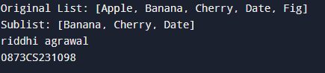

**. Write a Java program to compare two array lists.**

import java.util.ArrayList;

import java.util.Collections;

public class CompareArrayList {

public static void main(String[] args) {

ArrayList<String> list1 = new ArrayList<>();

list1.add("apple");

list1.add("banana");

list1.add("cherry");

ArrayList<String> list2 = new ArrayList<>();

list2.add("apple");

list2.add("banana");

list2.add("cherry");

ArrayList<String> list3 = new ArrayList<>();

list3.add("banana");

list3.add("apple");

list3.add("cherry");

ArrayList<String> list4 = new ArrayList<>();

list4.add("apple");

list4.add("banana");

// Comparing list1 and list2 (same elements and order)

System.out.println("list1 equals list2: " + list1.equals(list2)); // Output: true

// Comparing list1 and list3 (same elements, different order)

Collections.sort(list1);

Collections.sort(list3);

System.out.println("list1 equals list3 (after sorting): " + list1.equals(list3)); // Output: true

// Comparing list1 and list4 (different size)

System.out.println("list1 equals list4: " + list1.equals(list4));

System.out.println("riddhi agrawal");

System.out.println("0873CS231098");

}

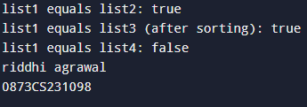

**Write a Java program that swaps two elements in an array list**

import java.util.ArrayList;

import java.util.Collections;

public class SwapArrayListElements {

public static void main(String[] args) {

ArrayList<String> list = new ArrayList<>();

list.add("Apple");

list.add("Banana");

list.add("Cherry");

list.add("Date");

System.out.println("Original list: " + list);

int index1 = 1; // Index of the first element to swap (Banana)

int index2 = 3; // Index of the second element to swap (Date)

swapElements(list, index1, index2);

System.out.println("List after swapping elements at indices " + index1 + " and " + index2 + ": " + list);

// Using the Collections.swap method

ArrayList<String> list2 = new ArrayList<>(list);

Collections.swap(list2, index1, index2);

System.out.println("List after swapping elements at indices " + index1 + " and " + index2 + " using Collections.swap: " + list2);

}

public static <T> void swapElements(ArrayList<T> list, int index1, int index2) {

if (index1 < 0 || index1 >= list.size() || index2 < 0 || index2 >= list.size()) {

throw new IndexOutOfBoundsException("Invalid index for swapping");

}

T temp = list.get(index1);

list.set(index1, list.get(index2));

list.set(index2, temp);

System.out.println("riddhi agrawal");

System.out.println("0873CS231098");

}

}

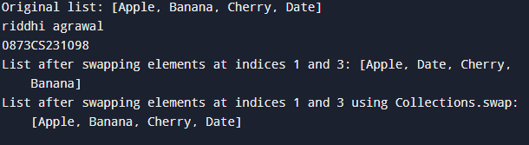

**. Write a Java program to join two array lists.**

import java.util.ArrayList;

public class JoinArrayLists {

public static void main(String[] args) {

ArrayList<String> list1 = new ArrayList<>();

list1.add("Apple");

list1.add("Banana");

ArrayList<String> list2 = new ArrayList<>();

list2.add("Cherry");

list2.add("Date");

ArrayList<String> joinedList = new ArrayList<>();

joinedList.addAll(list1);

joinedList.addAll(list2);

System.out.println("Joined List: " + joinedList);

System.out.println("riddhi agrawal");

System.out.println("0873CS231098");

}

}

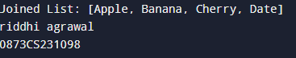

**Write a Java program to clone an array list to another array list**

import java.util.ArrayList;

public class ArrayListClone {

public static void main(String[] args) {

ArrayList<String> originalList = new ArrayList<>();

originalList.add("Apple");

originalList.add("Banana");

originalList.add("Cherry");

ArrayList<String> clonedList = (ArrayList<String>) originalList.clone();

System.out.println("Original List: " + originalList);

System.out.println("Cloned List: " + clonedList);

originalList.set(0, "Grape");

System.out.println("Original List after modification: " + originalList);

System.out.println("Cloned List after modification: " + clonedList);

ArrayList<String> clonedList2 = new ArrayList<>(originalList);

System.out.println("Original List: " + originalList);

System.out.println("Cloned List using constructor: " + clonedList2);

System.out.println("riddhi agrawal");

System.out.println("0873CS231098");

}

}

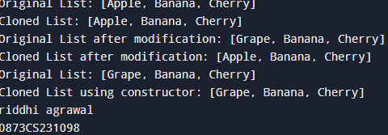

**. Write a Java program to empty an array list.in java**

import java.util.ArrayList;

public class EmptyArrayList {

public static void main(String[] args) {

// Create an ArrayList and add some elements

ArrayList<String> list = new ArrayList<>();

list.add("Apple");

list.add("Banana");

list.add("Orange");

System.out.println("ArrayList before clearing: " + list);

// Method 1: Using clear() method

list.clear();

System.out.println("ArrayList after clearing using clear(): " + list);

// Re-initialize the list to add elements again

list.add("Mango");

list.add("Grapes");

System.out.println("ArrayList before clearing again: " + list);

// Method 2: Creating a new empty ArrayList

list = new ArrayList<>();

System.out.println("ArrayList after clearing using new ArrayList(): " + list);

System.out.println("riddhi agrawal");

System.out.println("0873CS231098");

}

}

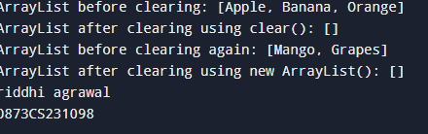

**Write a Java program to test whether an array list is empty or not.**

import java.util.ArrayList;

public class ArrayListEmptyCheck {

public static void main(String[] args) {

// Creating an empty ArrayList

ArrayList<String> emptyList = new ArrayList<>();

// Creating a non-empty ArrayList

ArrayList<String> filledList = new ArrayList<>();

filledList.add("Item 1");

filledList.add("Item 2");

// Checking if the ArrayList is empty using isEmpty() method

System.out.println("Is emptyList empty? " + emptyList.isEmpty()); // Output: true

System.out.println("Is filledList empty? " + filledList.isEmpty()); // Output: false

System.out.println("riddhi agrawal");

System.out.println("0873CS231098");

}

}

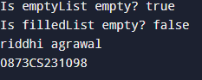

**Write a Java program to increase an array list size.**

import java.util.ArrayList;

public class ArrayListIncreaseSize {

public static void main(String[] args) {

// Create an ArrayList with an initial capacity

ArrayList<Integer> numbers = new ArrayList<>(5);

// Add elements to the ArrayList

numbers.add(10);

numbers.add(20);

numbers.add(30);

numbers.add(40);

numbers.add(50);

System.out.println("Initial ArrayList: " + numbers);

System.out.println("Initial size: " + numbers.size());

// Add more elements to increase the size

numbers.add(60);

numbers.add(70);

numbers.add(80);

System.out.println("ArrayList after adding more elements: " + numbers);

System.out.println("Size after adding more elements: " + numbers.size());

// You can also increase the size by adding elements at a specific index

numbers.add(2, 25); // Add 25 at index 2

System.out.println("ArrayList after inserting at index 2: " + numbers);

System.out.println("Size after inserting at index 2: " + numbers.size());

{ System.out.println("riddhi agrawal");

System.out.println("0873CS231098");

}}}

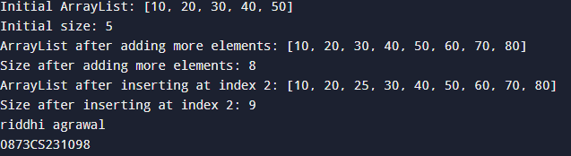

**. Write a Java program to replace the second element of an ArrayList with the specified element**

import java.util.ArrayList;

import java.util.Arrays;

public class ReplaceSecondElement {

public static void main(String[] args) {

// Create an ArrayList with initial values

ArrayList<String> list = new ArrayList<>(Arrays.asList("Apple", "Banana", "Cherry", "Date"));

// Specify the new element to replace the second element

String newElement = "Grape";

// Replace the element at index 1 (second element) with the new element

list.set(1, newElement);

// Print the updated ArrayList

System.out.println("Updated ArrayList: " + list);

{ System.out.println("riddhi agrawal");

System.out.println("0873CS231098");

}}}

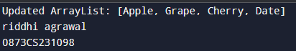

**Write a Java program to print all the elements of an ArrayList using the elements' position.**

import java.util.ArrayList;

public class ArrayListPrint {

public static void main(String[] args) {

ArrayList<String> list = new ArrayList<>();

list.add("Apple");

list.add("Banana");

list.add("Cherry");

list.add("Date");

// Iterate through the ArrayList using a for loop and get method

for (int i = 0; i < list.size(); i++) {

System.out.println("Element at index " + i + ": " + list.get(i));

}

}

}

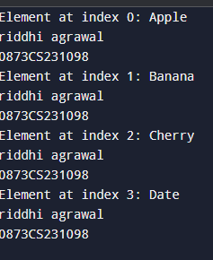

**Write a Java program to append a specified element to the end of a linked list.**

import java.util.LinkedList;

public class AppendLinkedList {

public static void main(String[] args) {

// Create a LinkedList

LinkedList<String> linkedList = new LinkedList<>();

// Add some initial elements to the LinkedList

linkedList.add("Apple");

linkedList.add("Banana");

linkedList.add("Cherry");

// Element to append

String elementToAppend = "Date";

// Append the element to the end of the LinkedList

linkedList.addLast(elementToAppend);

// Print the updated LinkedList

System.out.println("Updated LinkedList: " + linkedList);

}

} 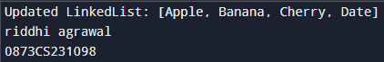

**Write a Java program to iterate through all elements in a linked list**

import java.util.LinkedList;

import java.util.Iterator;

public class LinkedListIteration {

public static void main(String[] args) {

// Create a LinkedList

LinkedList<String> linkedList = new LinkedList<>();

linkedList.add("Apple");

linkedList.add("Banana");

linkedList.add("Cherry");

// Method 1: Using a for-each loop (enhanced for loop)

System.out.println("Method 1: Using for-each loop");

for (String element : linkedList) {

System.out.println(element);

}

// Method 2: Using an Iterator

System.out.println("\nMethod 2: Using an Iterator");

Iterator<String> iterator = linkedList.iterator();

while (iterator.hasNext()) {

System.out.println(iterator.next());

}

// Method 3: Using a traditional for loop (index-based access)

System.out.println("\nMethod 3: Using traditional for loop");

for (int i = 0; i < linkedList.size(); i++) {

System.out.println(linkedList.get(i));

}

System.out.println("riddhi agrawal");

System.out.println("0873CS231098");

}}

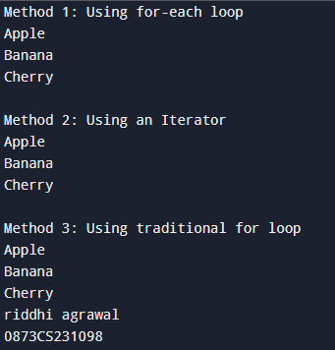

**Write a Java program to iterate through all elements starting from a specified position in a linked list.**

import java.util.LinkedList;

import java.util.ListIterator;

public class LinkedListIteration {

public static void main(String[] args) {

LinkedList<String> linkedList = new LinkedList<>();

linkedList.add("Apple");

linkedList.add("Banana");

linkedList.add("Cherry");

linkedList.add("Date");

linkedList.add("Fig");

int startIndex = 2; // Start from the 3rd element (index 2)

iterateFromPosition(linkedList, startIndex);

}

public static void iterateFromPosition(LinkedList<String> list, int startIndex) {

if (startIndex < 0 || startIndex >= list.size()) {

System.out.println("Invalid start index.");

return;

}

ListIterator<String> iterator = list.listIterator(startIndex);

while (iterator.hasNext()) {

System.out.println(iterator.next());

}

System.out.println("riddhi agrawal");

System.out.println("0873CS231098");

}}

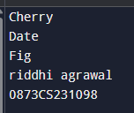

**Write a Java program to iterate a linked list in reverse order.**

import java.util.LinkedList;

import java.util.Stack;

public class ReverseLinkedList {

public static void main(String[] args) {

LinkedList<Integer> list = new LinkedList<>();

list.add(1);

list.add(2);

list.add(3);

list.add(4);

list.add(5);

System.out.println("Original List: " + list);

System.out.print("Reversed List: ");

reverseIterate(list);

}

public static void reverseIterate(LinkedList<Integer> list) {

Stack<Integer> stack = new Stack<>();

for (Integer num : list) {

stack.push(num);

}

while (!stack.isEmpty()) {

System.out.print(stack.pop() + " ");

}

System.out.println();

System.out.println("riddhi agrawal");

System.out.println("0873CS231098");

}}

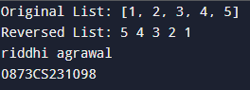

**Write a Java program to insert a specified element at a given position in a linked list.**

import java.util.LinkedList;

public class LinkedListInsertion {

public static void main(String[] args) {

LinkedList<String> list = new LinkedList<>();

list.add("Apple");

list.add("Banana");

list.add("Date");

System.out.println("Original List: " + list);

insertElement(list, "Cherry", 1);

System.out.println("List after insertion: " + list);

insertElement(list, "Fig", 4);

System.out.println("List after insertion: " + list);

insertElement(list, "Grape", 0);

System.out.println("List after insertion: " + list);

}

public static void insertElement(LinkedList<String> list, String element, int position) {

if (position < 0 || position > list.size()) {

System.out.println("Invalid position for insertion.");

return;

}

list.add(position, element);

System.out.println("riddhi agrawal");

System.out.println("0873CS231098");

}}

